Initial Length Analysis

Sample Sizes
len.fr.bin 3 5 7 9 11 13 15 17
tx stage
8BF Fem 0 0 0 11 4 5 4 0
Grav 0 0 0 0 0 0 0 0
Juv 0 0 9 3 0 0 0 0
Male 0 0 0 1 5 12 0 0
8SBF Fem 0 0 2 15 16 6 12 5
Grav 0 0 0 0 0 4 6 2
Juv 10 10 11 4 0 0 0 0
Male 0 0 0 6 16 9 0 0

Two-week loss of length
> lm1 <- lm(loss.p2w~len.fr*stage*tx)
> Anova(lm1)
Anova Table (Type II tests)

Response: loss.p2w
Sum Sq Df F value Pr(>F)
len.fr 0.3325 1 1.7964 0.18252
stage 0.0679 2 0.1834 0.83267
tx 1.8613 1 10.0568 0.00190 **
len.fr:stage 1.6867 2 4.5568 0.01225 *
len.fr:tx 0.8846 1 4.7797 0.03062 *
stage:tx 0.1506 2 0.4067 0.66669
len.fr:stage:tx 0.6555 2 1.7708 0.17435
Residuals 23.6901 128

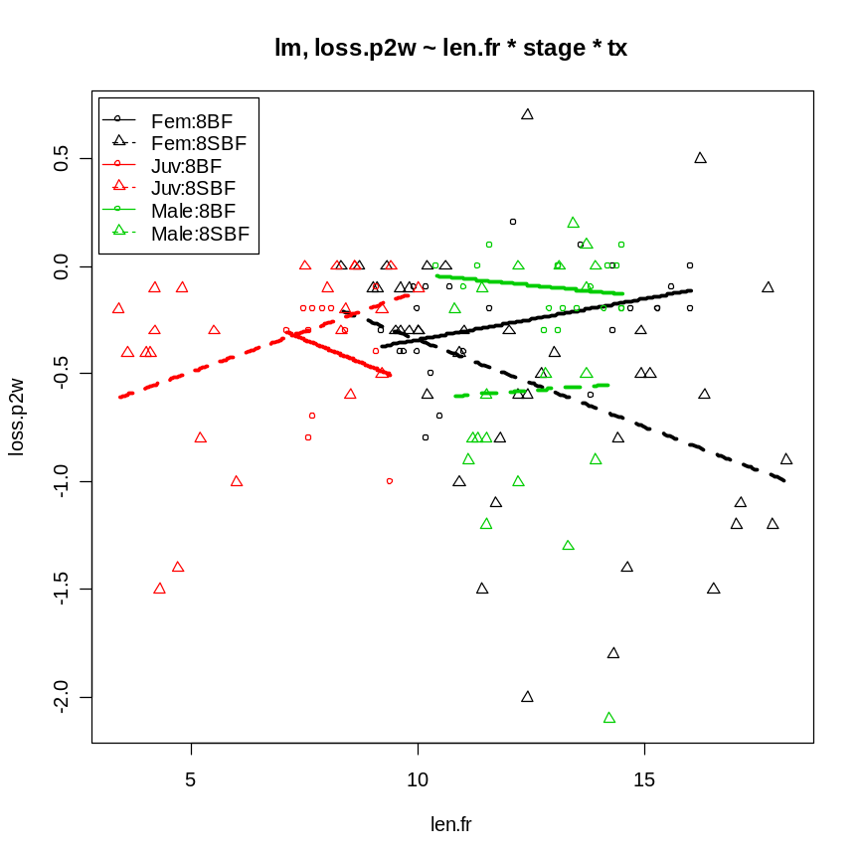

Proportional loss in length after 2 weeks
> lm2 <- lm(ploss.p2w~len.fr*stage*tx)
> Anova(lm2)
Anova Table (Type II tests)

Response: ploss.p2w
Sum Sq Df F value Pr(>F)
len.fr 0.005992 1 2.8848 0.09185 .
stage 0.002108 2 0.5073 0.60331
tx 0.010049 1 4.8378 0.02964 *
len.fr:stage 0.048952 2 11.7835 2.008e-05 ***
len.fr:tx 0.002970 1 1.4297 0.23403
stage:tx 0.001903 2 0.4580 0.63360
len.fr:stage:tx 0.008290 2 1.9956 0.14014
Residuals 0.265877 128

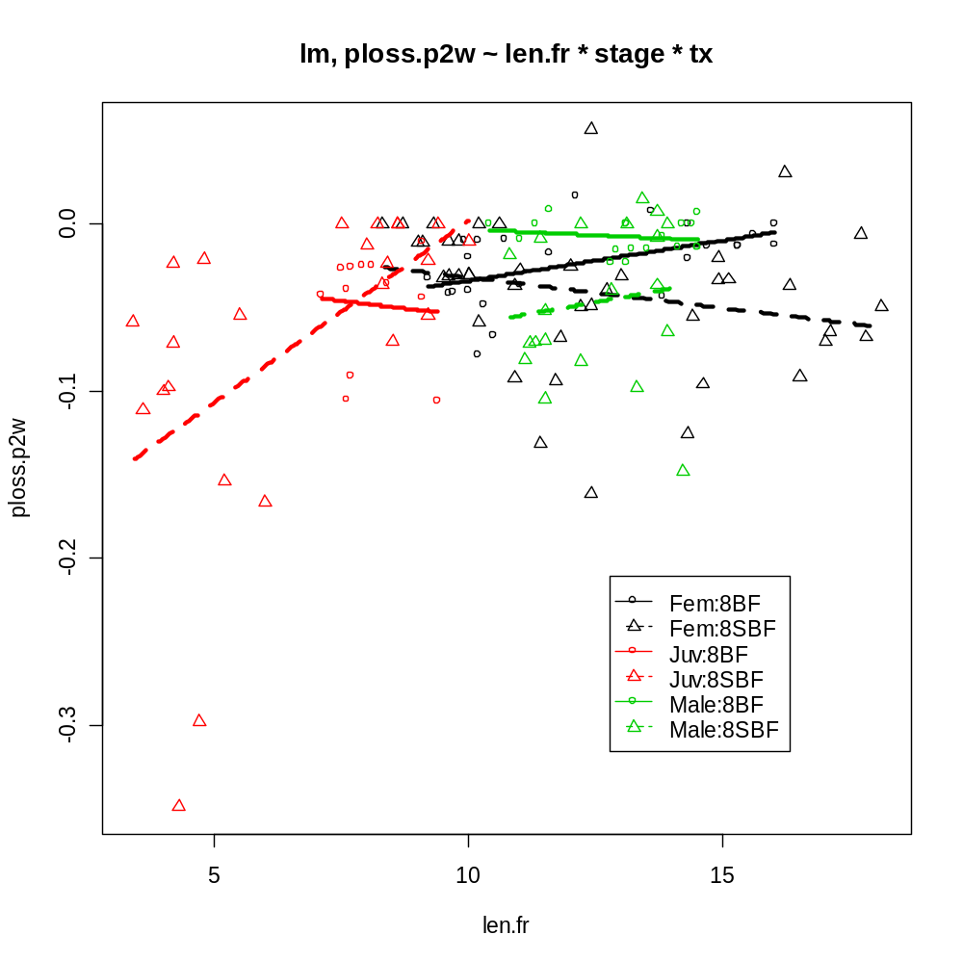

Proportional loss in length in two weeks – only for those greater than 5 mm

> lm2 <- lm(ploss.p2w~len.fr*stage*tx)
> Anova(lm2)
Anova Table (Type II tests)

Response: ploss.p2w
Sum Sq Df F value Pr(>F)
len.fr 0.000550 1 0.4722 0.49334
stage 0.000143 2 0.0615 0.94038
tx 0.006885 1 5.9078 0.01661 *
len.fr:stage 0.000294 2 0.1261 0.88166
len.fr:tx 0.004717 1 4.0479 0.04654 *
stage:tx 0.003646 2 1.5643 0.21362
len.fr:stage:tx 0.002880 2 1.2357 0.29444
Residuals 0.135179 116

